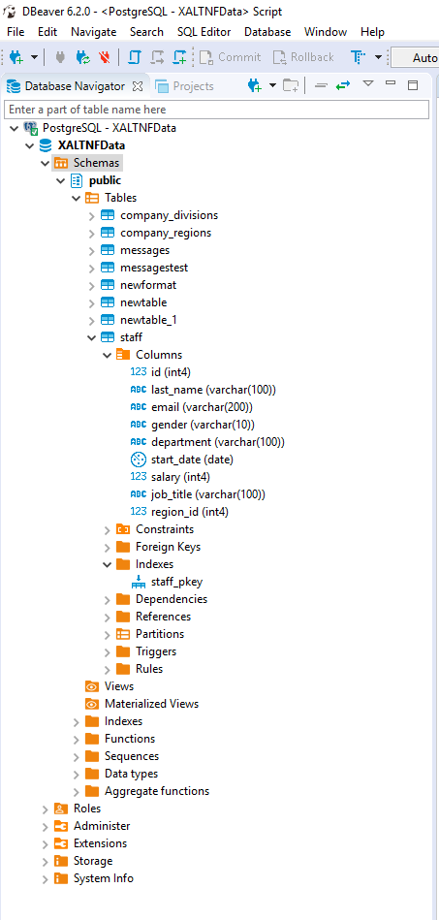

**select** * **from** staff

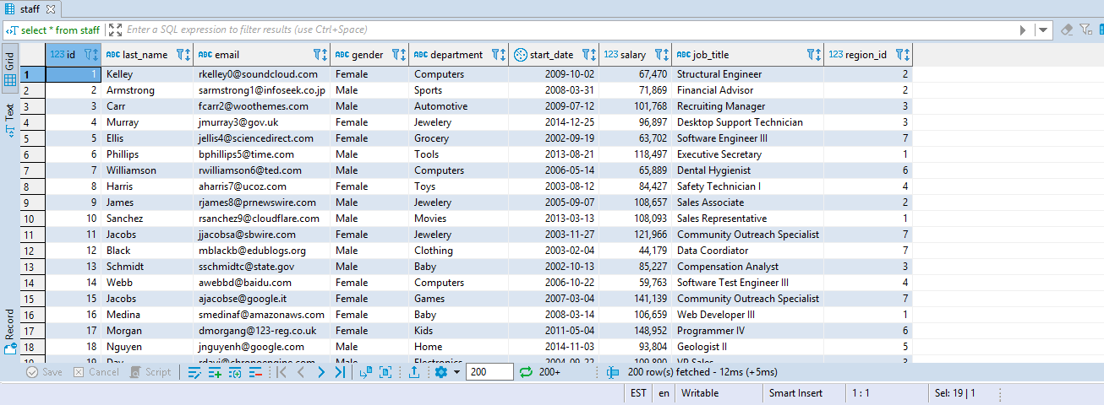

**QUERY OPTIMIZATION**

**EXPLAIN** **select** * **from** staff

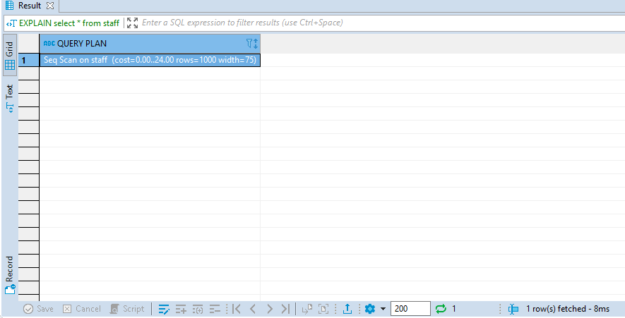

**SHOW BOTH PLANNING & EXECUTION TIME**

**EXPLAIN** **ANALYZE** **select** * **from** staff

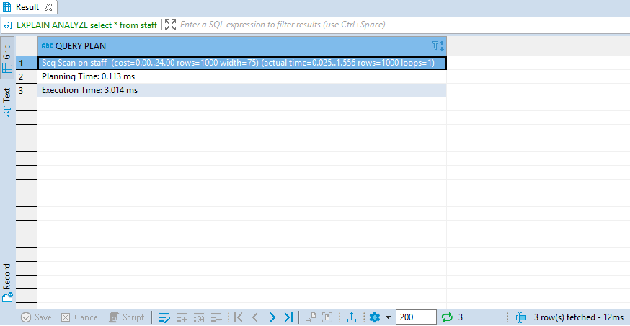

* Greater width value indicates larger rows are returned, indicating the size of the Table.
* Less width value indicates a smaller number of rows are returned, indicating the size of the Table is smaller.

**LESS WIDTH VALUE INDICATES LESS DATA EXTRACTION**

**EXPLAIN** **ANALYZE** **select** last_name **from** staff

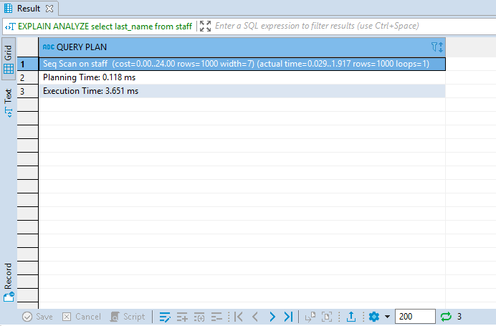

* Note the width is just 7, indicating lesser number of rows are returned.

**VARY THE EXECUTION TIME WHILE RUNNING THE QUERY**

**explain** **analyze** **select** * **from** staff

**where** salary > 75000

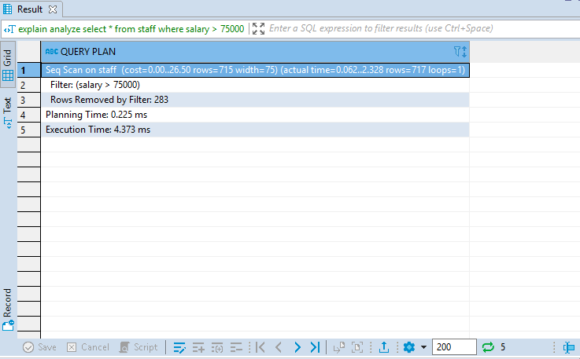

* Running the same query with/out the WHERE Clause shows the actual time required to run the Query.
* This query also shows the number of rows filtered with the WHERE Clause, along with both the Planning & the Execution Timing.
* Run the Query with/out the WHERE Clause and check how the cost value varies along with the Planning & the Execution Timing.

**CREATING INDEX**

**CREATE** **INDEX** idx_staff_salary **on** staff(salary)

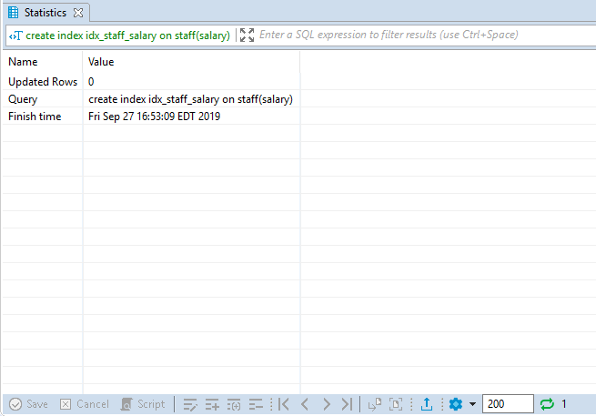

**DATA MODEL EXAMPLE**

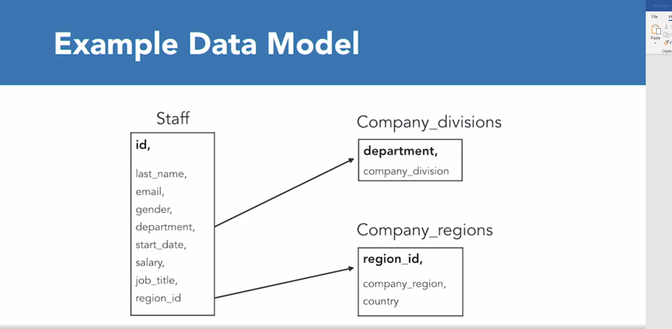

**USING INDEX TO GET DATA INSTEAD OF DOING A FULL TABLE SCAN**

* Some of the best uses of using Index is to reduce Execution & Computation Time.
* Before creating the Index as shown below, use EXPLAIN with ANALYZE in the SELECT statement to check the Execution & the Planning Time.
* Notice the reduction in cost and time after creating the Index

**CREATE** **INDEX** idx_staff_email **on** staff(email);

**EXPLAIN** **select** * **from** staff

**where** email = 'bphillips5@time.com'

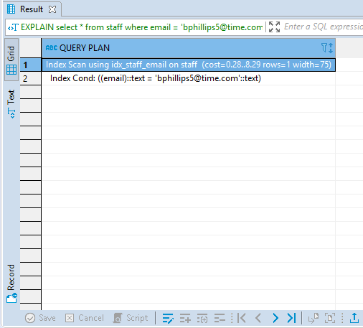

**CREATING BITMAP INDEX ON THE FLY**

**select** * **from** staff

**where** job_title = 'Operator'

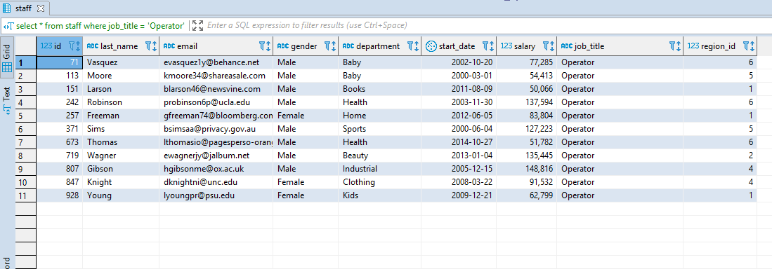

* Returns 11 Rows
* Let’s check the Cost with the Explain Statement

**explain** **select** * **from** staff

**where** job_title = 'Operator'

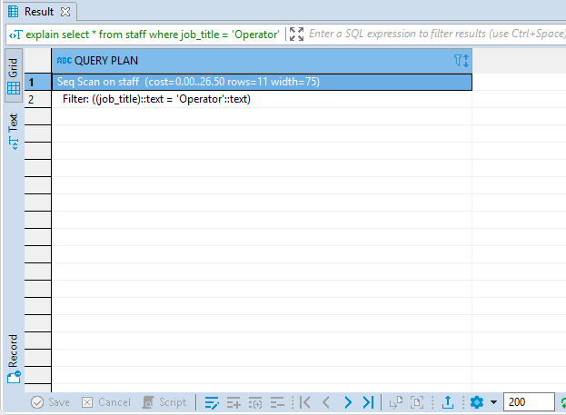

* Okay, now let’s create INDEX for faster data retrieval

**create** **index** idx_staff_job_title **on** staff(job_title);

**select** * **from** staff

**where** job_title = 'Operator'

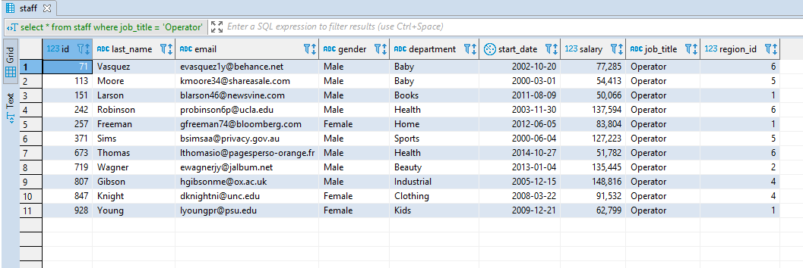

* Notice fetches the same result as before using the Index
* Use Explain in the same statement to look at it on the performance.

**SPECIALIZED INDEXES**

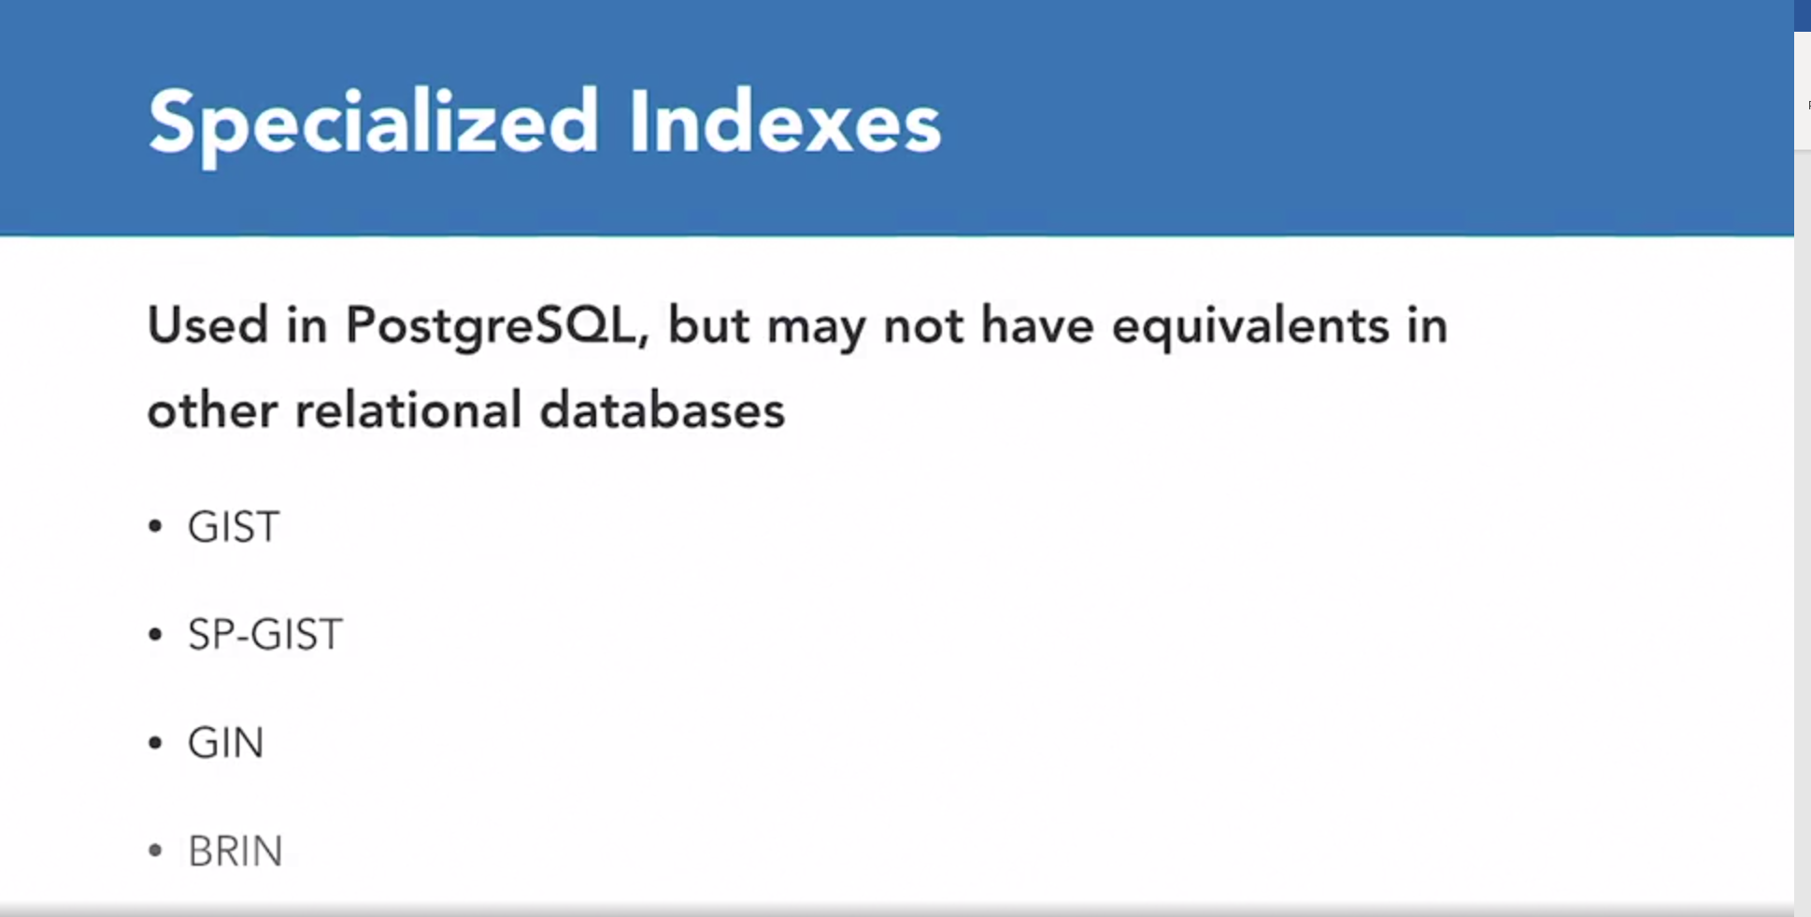

**TYPES OF JOINS**

1. **INNER JOIN**
2. **LEFT OUTER JOIN**
3. **RIGHT OUTER JOIN**
4. **FULL OUTER JOIN**

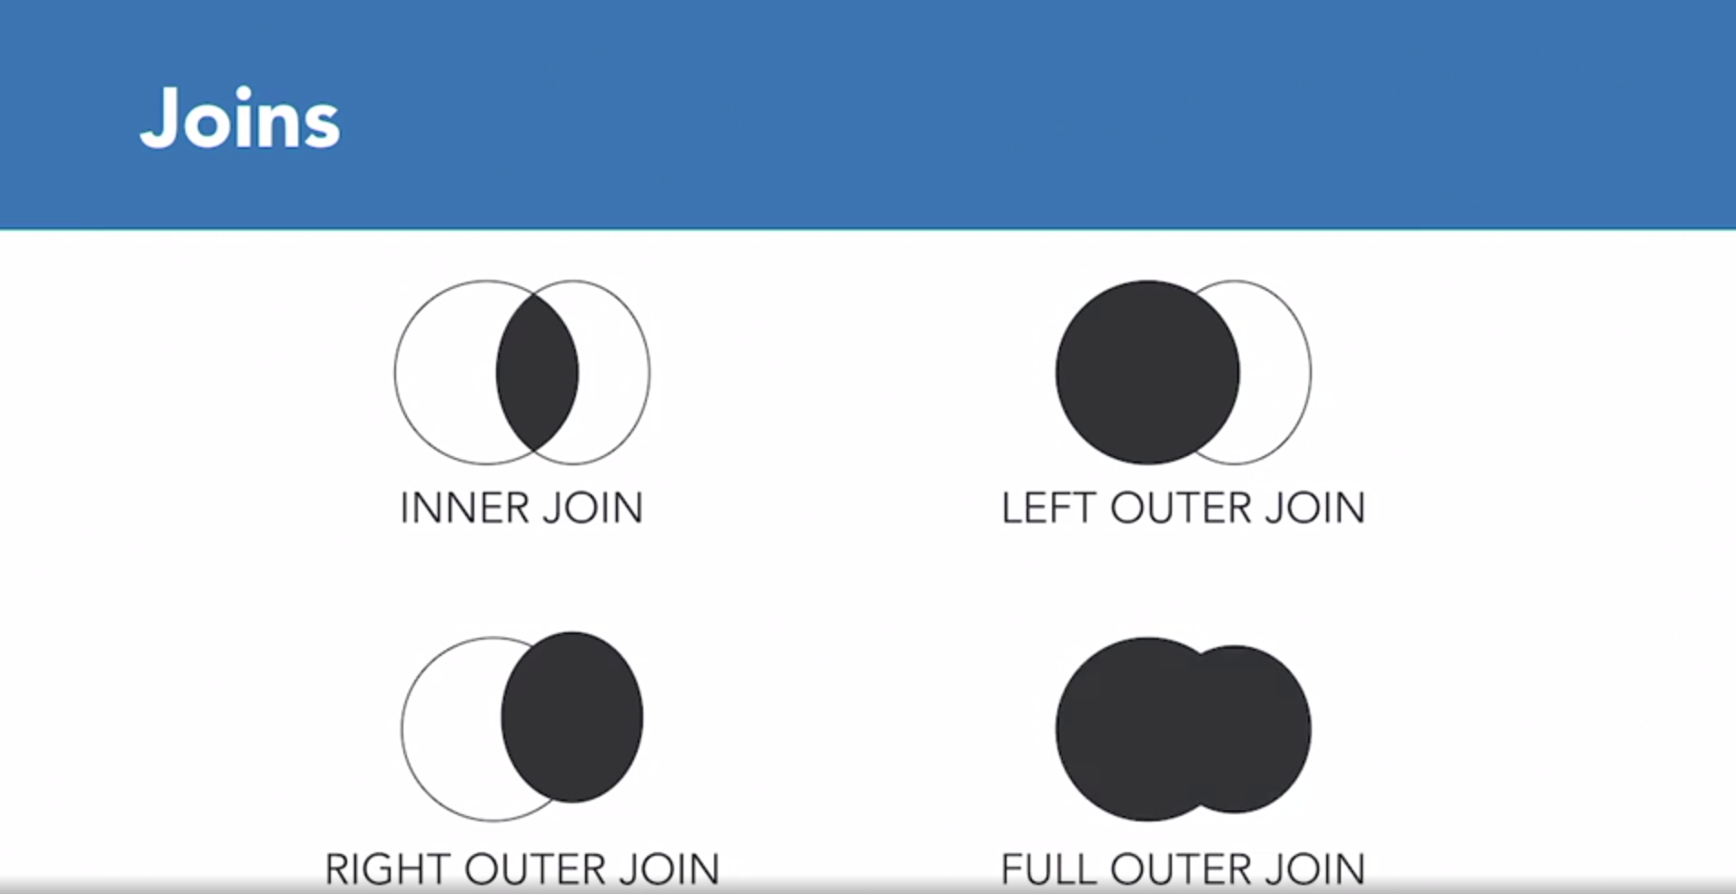

***INNER JOIN:***

* Returns matching rows from both the tables on the same variable

**select** *

**from** company_regions cr

**inner** **join** staff s

**on** cr.region_id = s.region_id

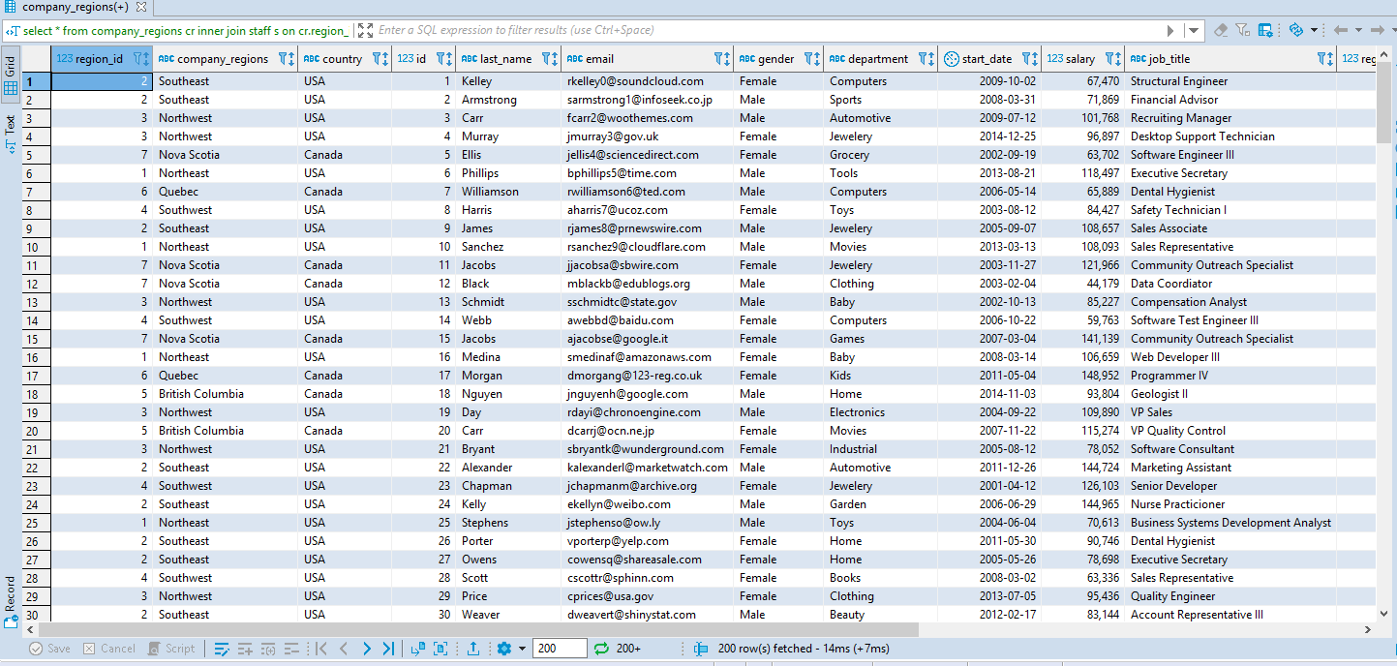

***LEFT OUTER JOIN:***

* Returns all Rows from left table
* Returns Rows from right table that have matching key
* Results might vary based on which Table is joined on left and which one on the right

**select** *

**from** company_regions cr

**left** **outer** **join** staff s

**on** cr.region_id = s.region_id

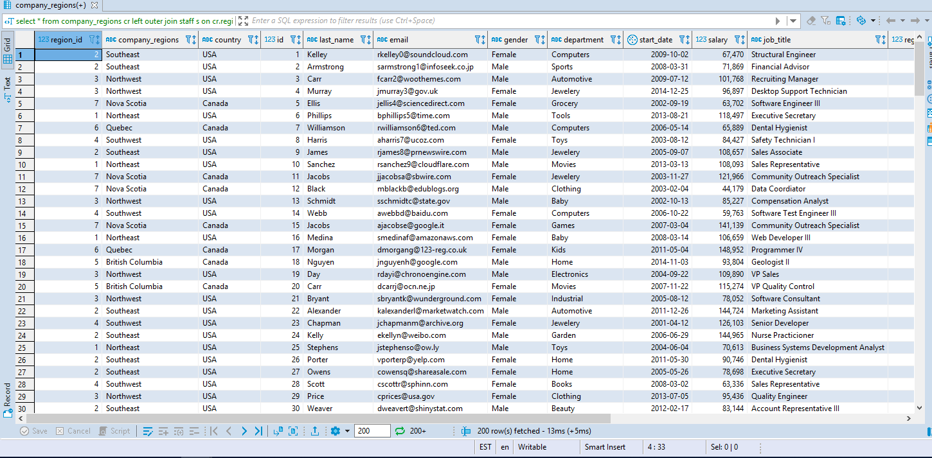

***RIGHT OUTER JOIN***

* Returns all Rows from right table
* Returns Rows from left table that have a matching key

**select** *

**from** company_regions cr

**right** **outer** **join** staff s

**on** cr.region_id = s.region_id

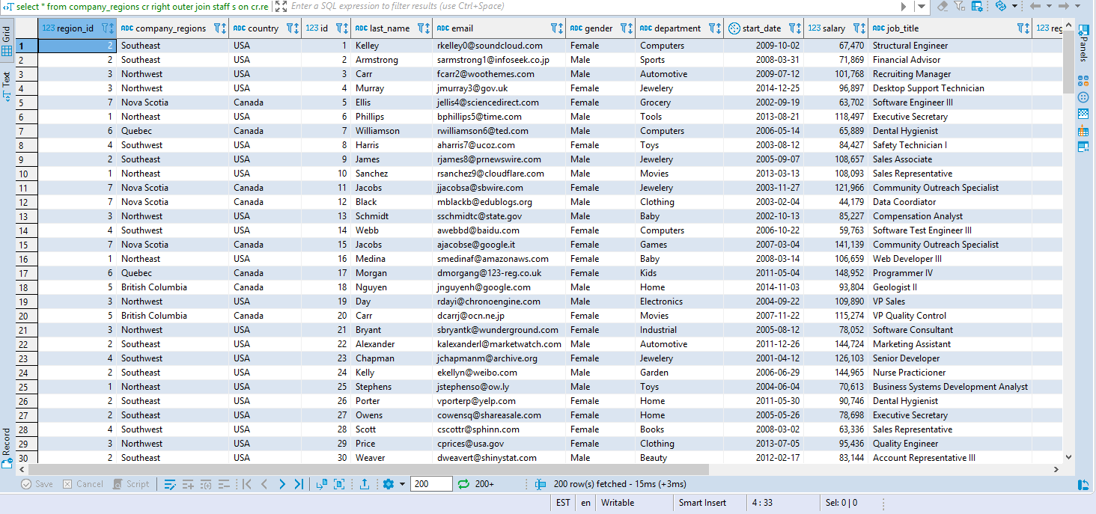

***FULL OUTER JOIN***

* Returns all Rows from both tables

**select** *

**from** company_regions cr

**full** **outer** **join** staff s

**on** cr.region_id = s.region_id

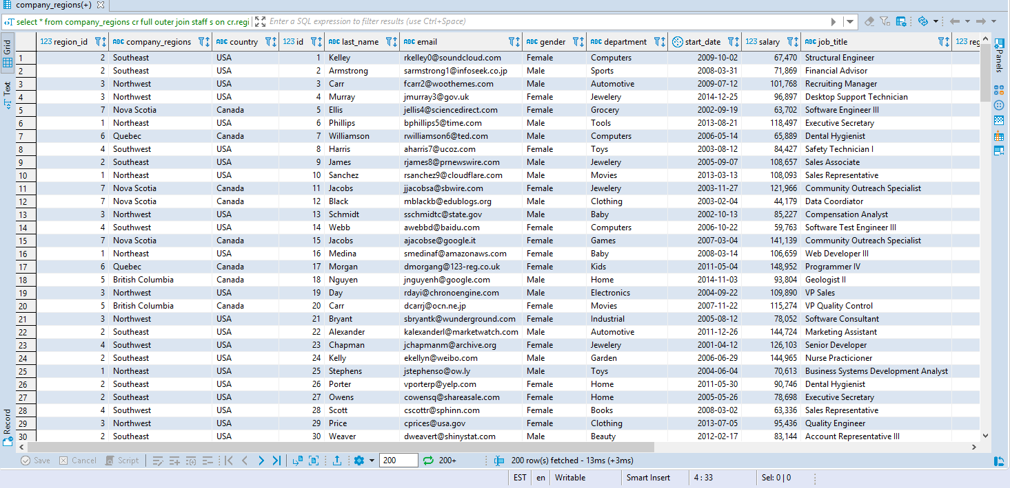

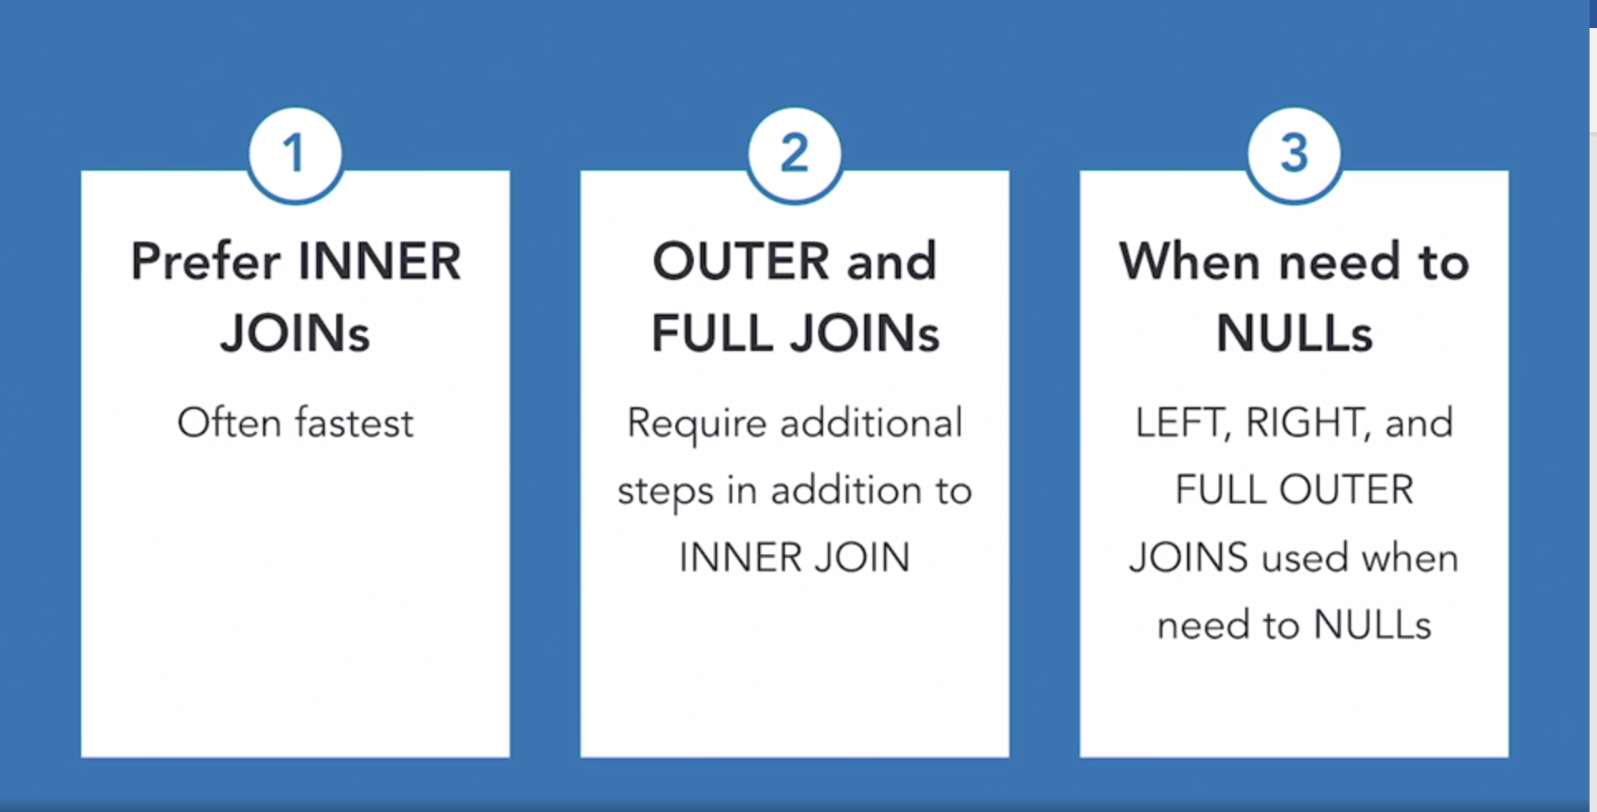

**NESTED LOOPS**

**select**

s.id, s.last_name, s.job_title, cr.country

**from**

staff s

**inner** **join**

company_regions cr

**on**

s.region_id = cr.region_id

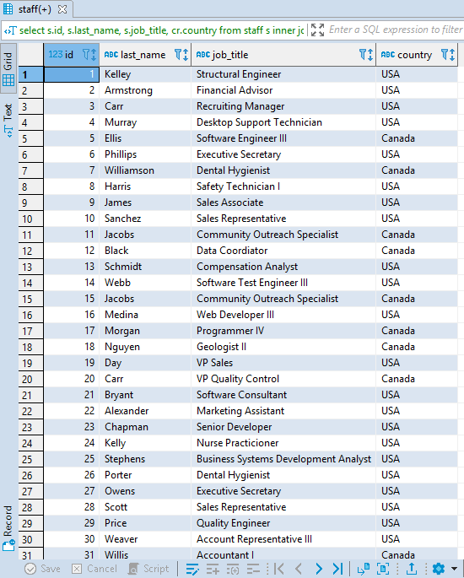

* Let’s check the quality performance of the query below.
* The query did not perform a nested loop but computed a Hash Join

**explain** **select**

s.id, s.last_name, s.job_title, cr.country

**from**

staff s

**inner** **join**

company_regions cr

**on**

s.region_id = cr.region_id

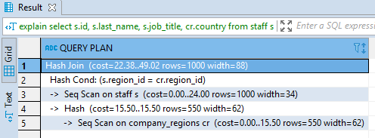

**Let’s force the query builder to show the Nested Loop. More efficient way of changing the query to Nesting Loop. Make sure to index Foreign Key column for reducing cost of running the query in the server.**

**set** enable_nestloop=**true**;

**set** enable_hashjoin=**false**;

**set** enable_mergejoin=**false**;

**explain** **select**

s.id, s.last_name, s.job_title, cr.country

**from**

staff s

**inner** **join**

company_regions cr

**on**

s.region_id = cr.region_id

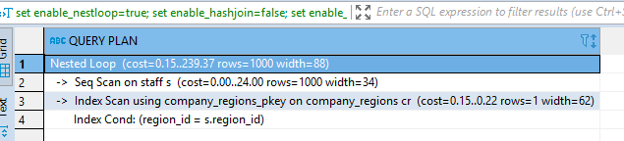

**HASH JOINS**

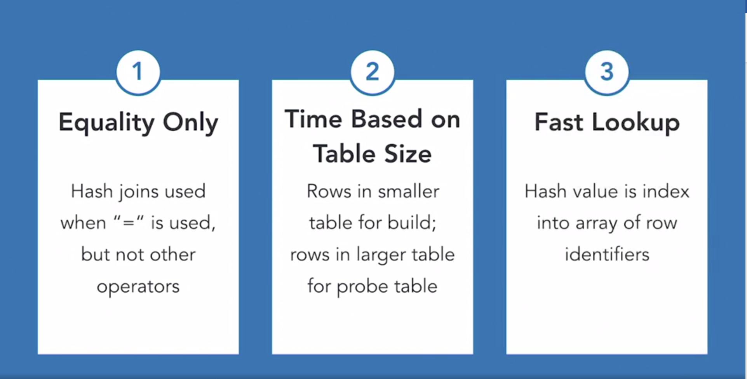

* Hash Table is built on the **company_regions** table
* The total cost of joins is just under 24 computational units

**set** enable_nestloop=**false**;

**set** enable_hashjoin=**true**;

**set** enable_mergejoin=**true**;

**explain** **select**

s.id, s.last_name, s.job_title, cr.country

**from**

staff s

**inner** **join**

company_regions cr

**on**

s.region_id = cr.region_id

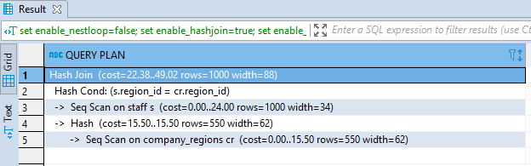

**MERGE JOINS**

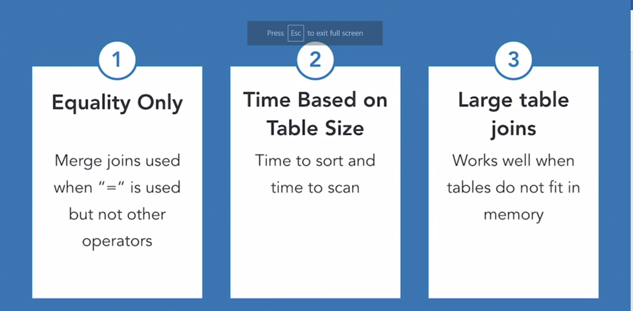

**set** enable_nestloop=**false**;

**set** enable_hashjoin=**false**;

**set** enable_mergejoin=**true**;

**explain** **select**

s.id, s.last_name, s.job_title, cr.country

**from**

staff s

**inner** **join**

company_regions cr

**on**

s.region_id = cr.region_id

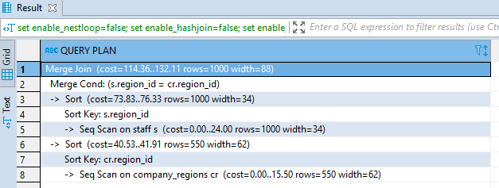

* Can use directives to do computational cost methods and proceed accordingly.
* Can select either of the Joins based on the needs and requirements to reduce the computational cost.

**SELECTING BETWEEN JOINS & SUBQUERIES**

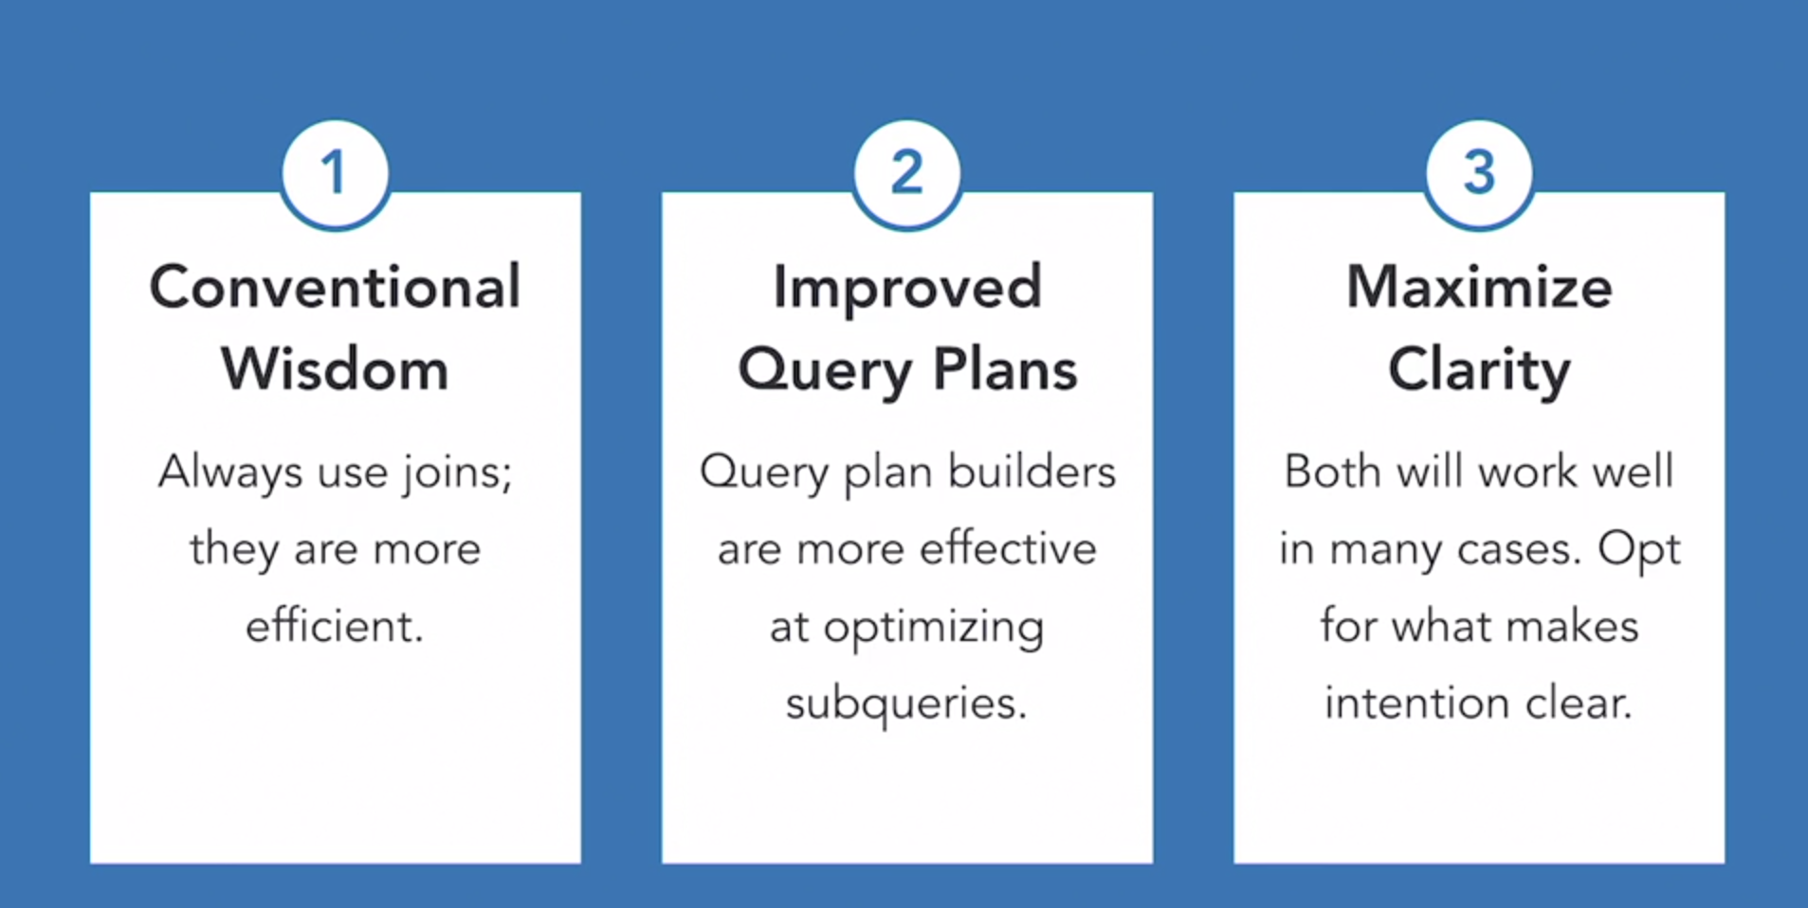

**DATA PARTITIONNING**

1. Horizontal Partitioning

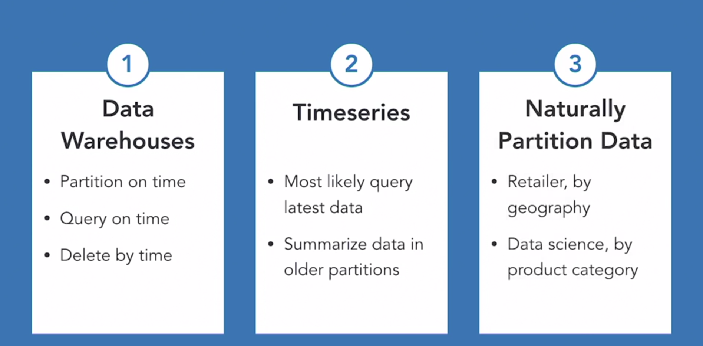

1. Vertical Partitioning

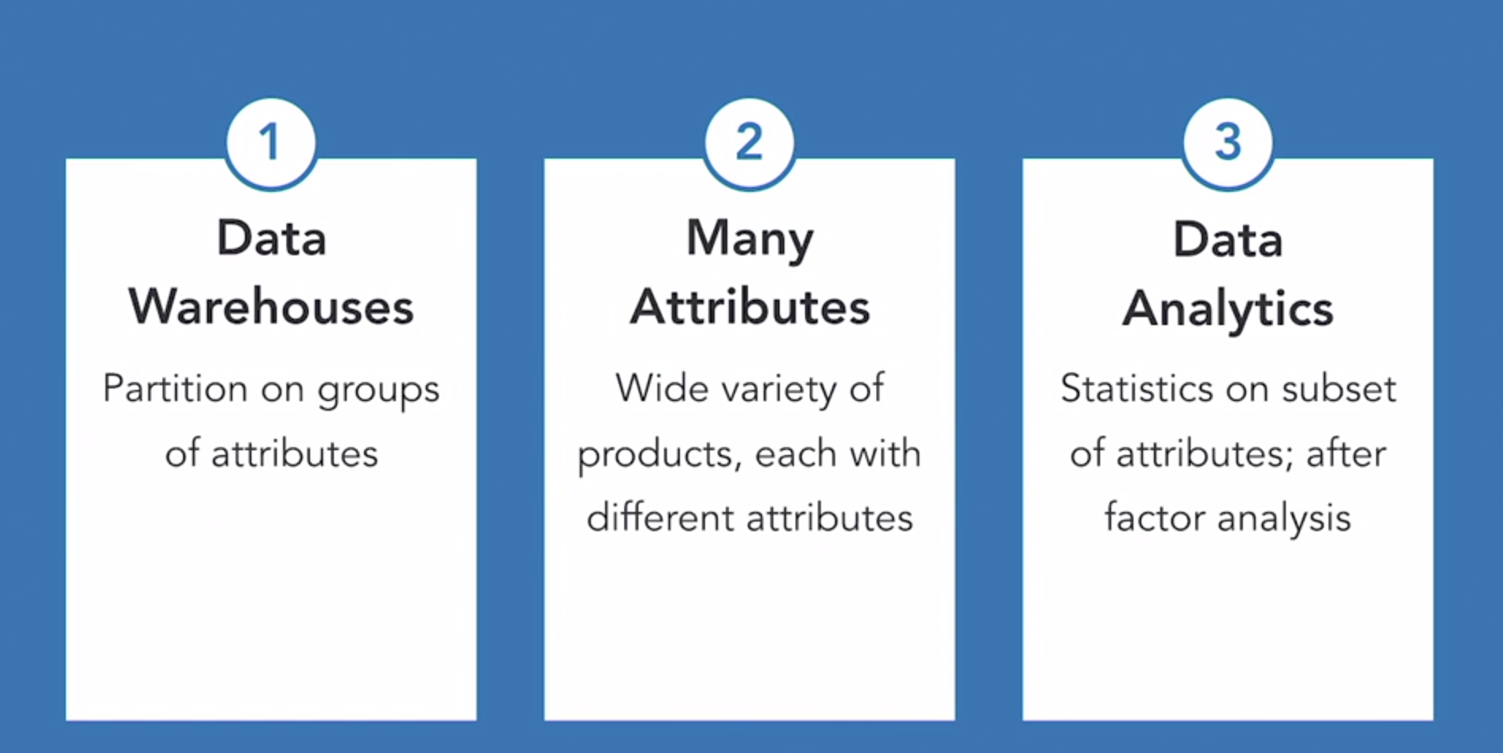

**PARTITION BY RANGE**

* IoT example, where partitioning is done based on each week.
* Used mainly when we query the latest data.
* Drop data after a period.

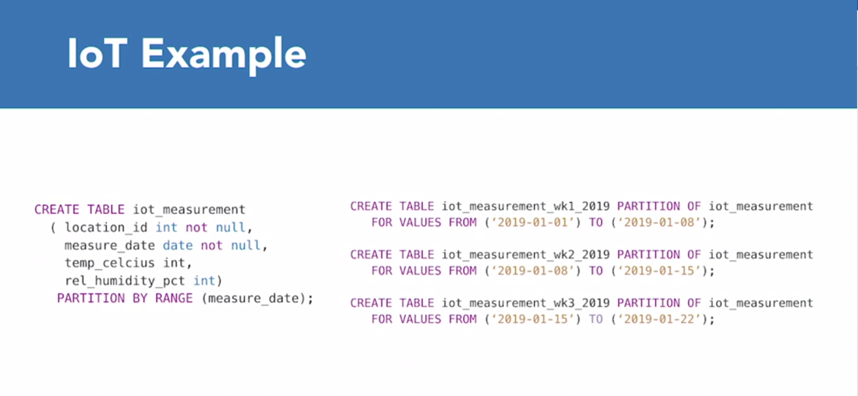

1. Let’s first create the Table IoT Measurement.

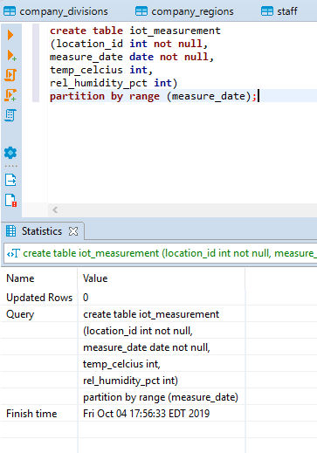

1. We can see the Table iot_measuremnt in the Table Schema along with the Partition

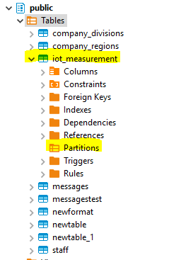

1. As, we can see from the Schema we do not have any Partitions index build out yet.
2. Let’s create Partitions based on weeks:

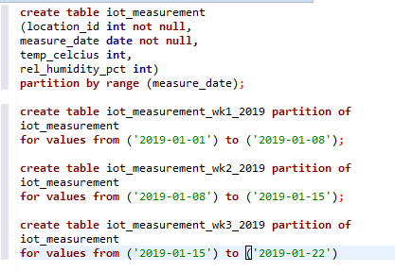

1. On refreshing the tables, the Partitioning for the 3 weeks come up. Notice each Partition has their Constrains, Trigger, Indexes that can be further created. However, these Partitions do not have any Columns because each of the Columns for the Partitions are already there within the Table.

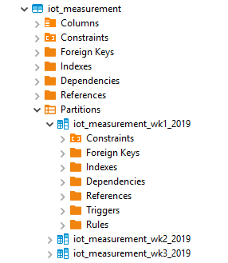

**PARTITION BY LIST**

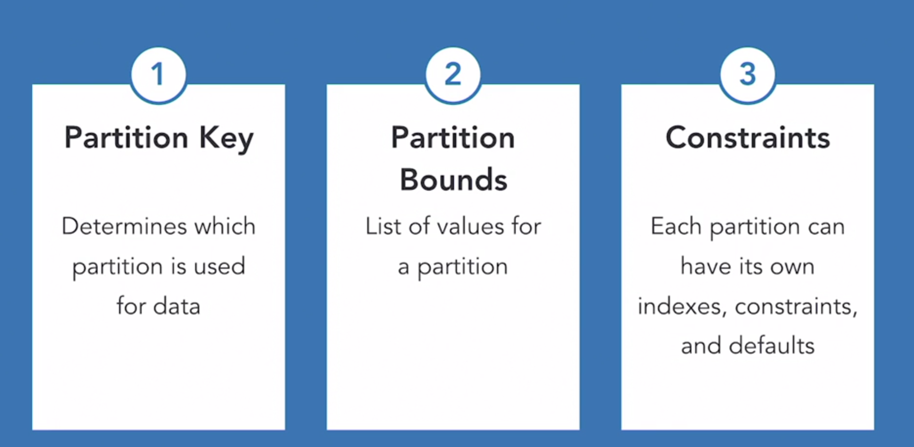

* An example of Partitioning example, partitioning similar values together in a group:

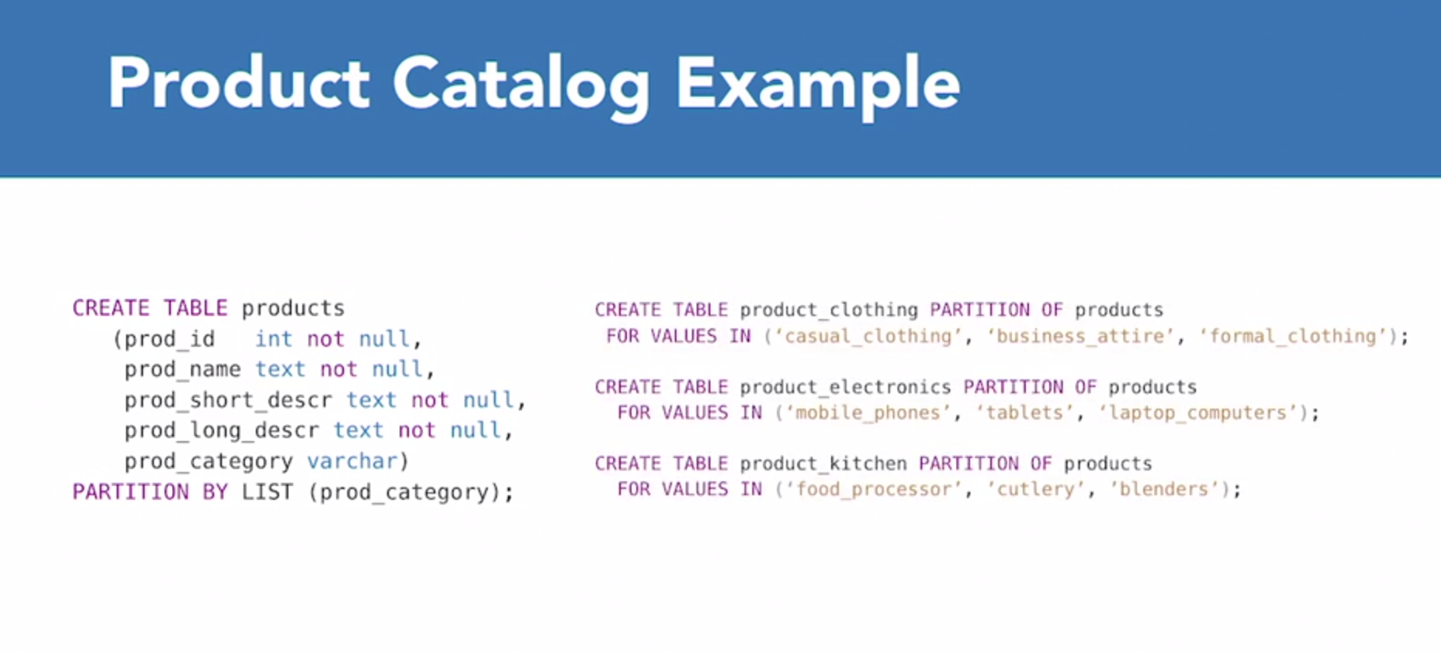

* Use when data is not time oriented.

1. A snip of the Product Table from the PostgreSQL:

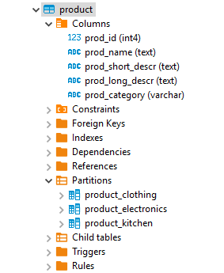

**HASH PARTITIONING**

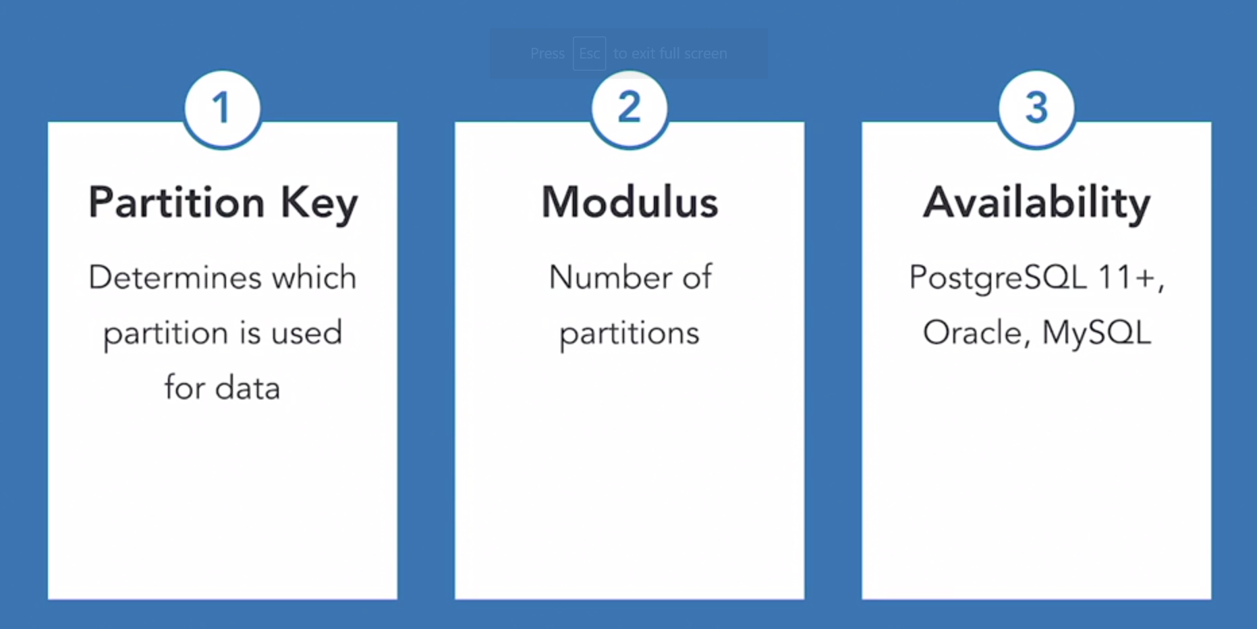

* Used when data does NOT logically group into subgroups.
* Even data distributions across Partitions expected.
* No need for sup-group specific operations such as drop a partition.

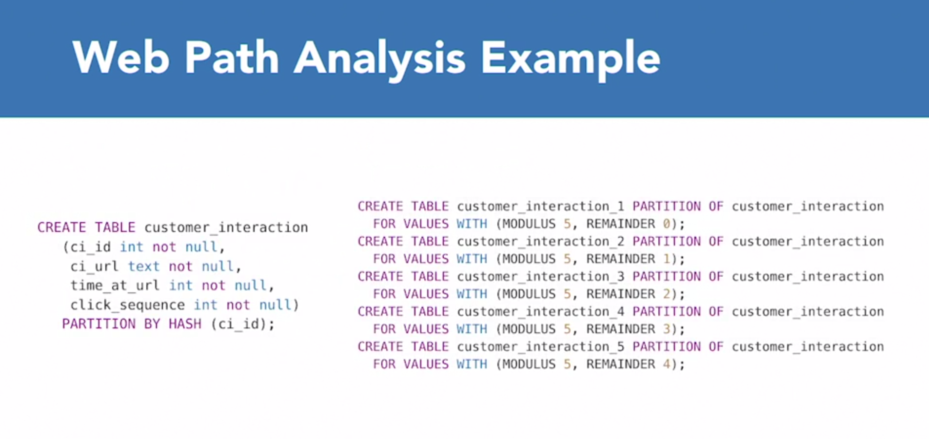

**MATERIALIZED VIEWS**

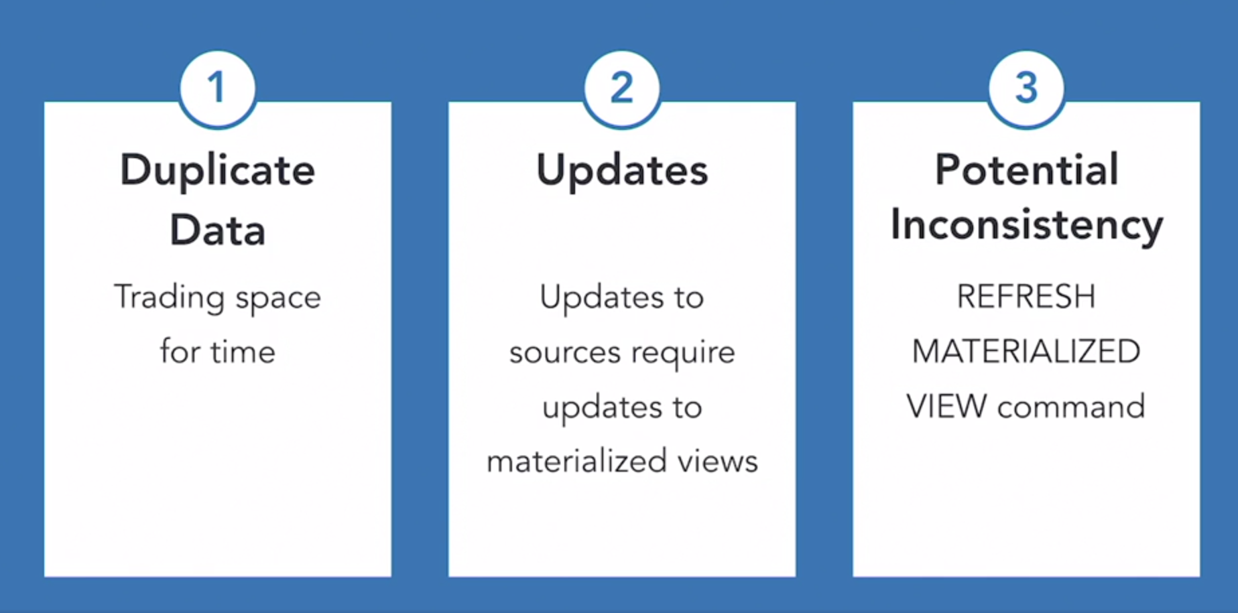

* Saving time in query execution more important than storage space.
* Can refresh after each update to sources.

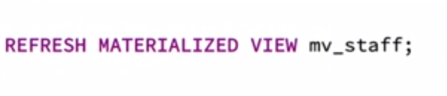

* Each time a View is Refreshed, each time the View gets updated with the new data added to the Source Tables.
* Can create indexes on Materialized Views.
* Saves data from Source to new Data Structure in the Views.

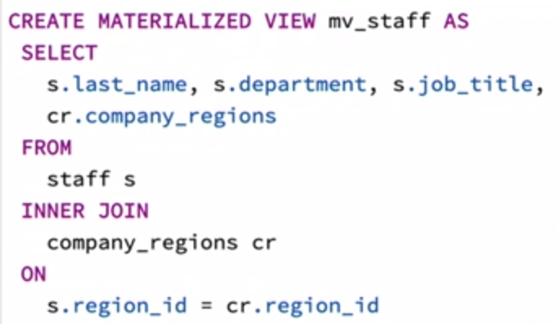

**OPTIMIZATION TECHNIQUES**

* Try to understand the data distribution, either Positive or Negative Skewed.
* Negative Skewed: Distribution with more instances toward larger values.
* Positive Skewed: Distribution more towards the lower end of the Range.

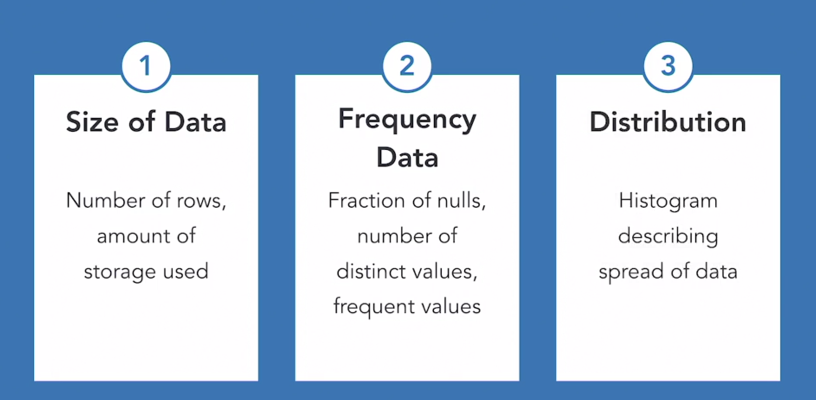

* Other data optimization techniques:

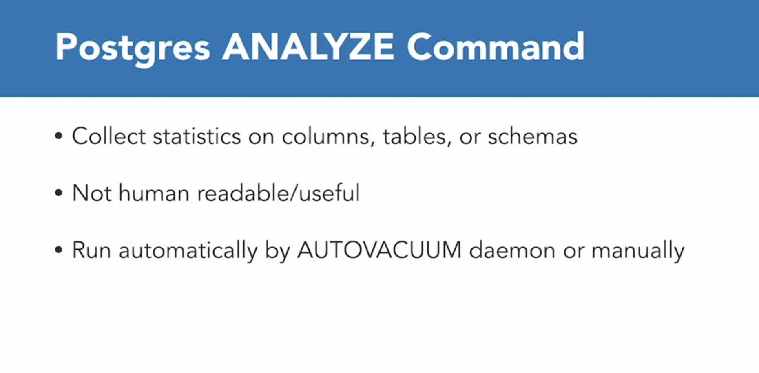

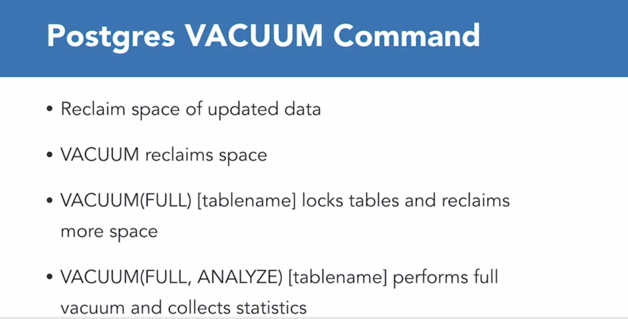

* When required to rebuild the corrupt indexes.

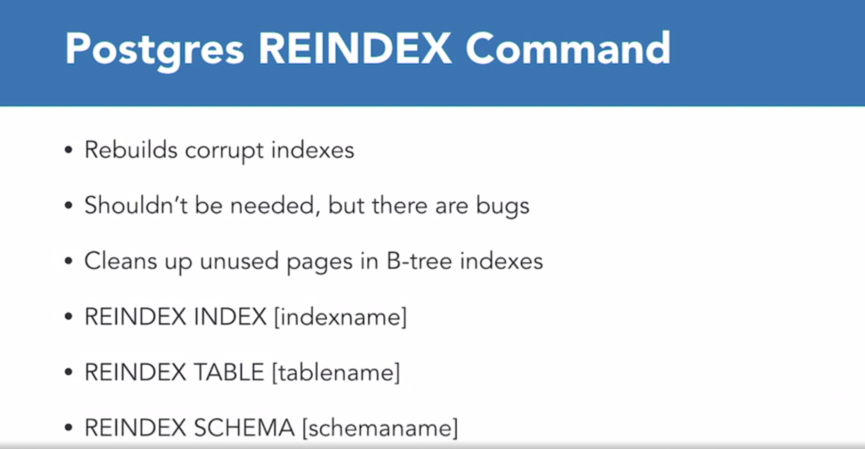

* **Use prudence on using “Hints” for Query Optimization.**

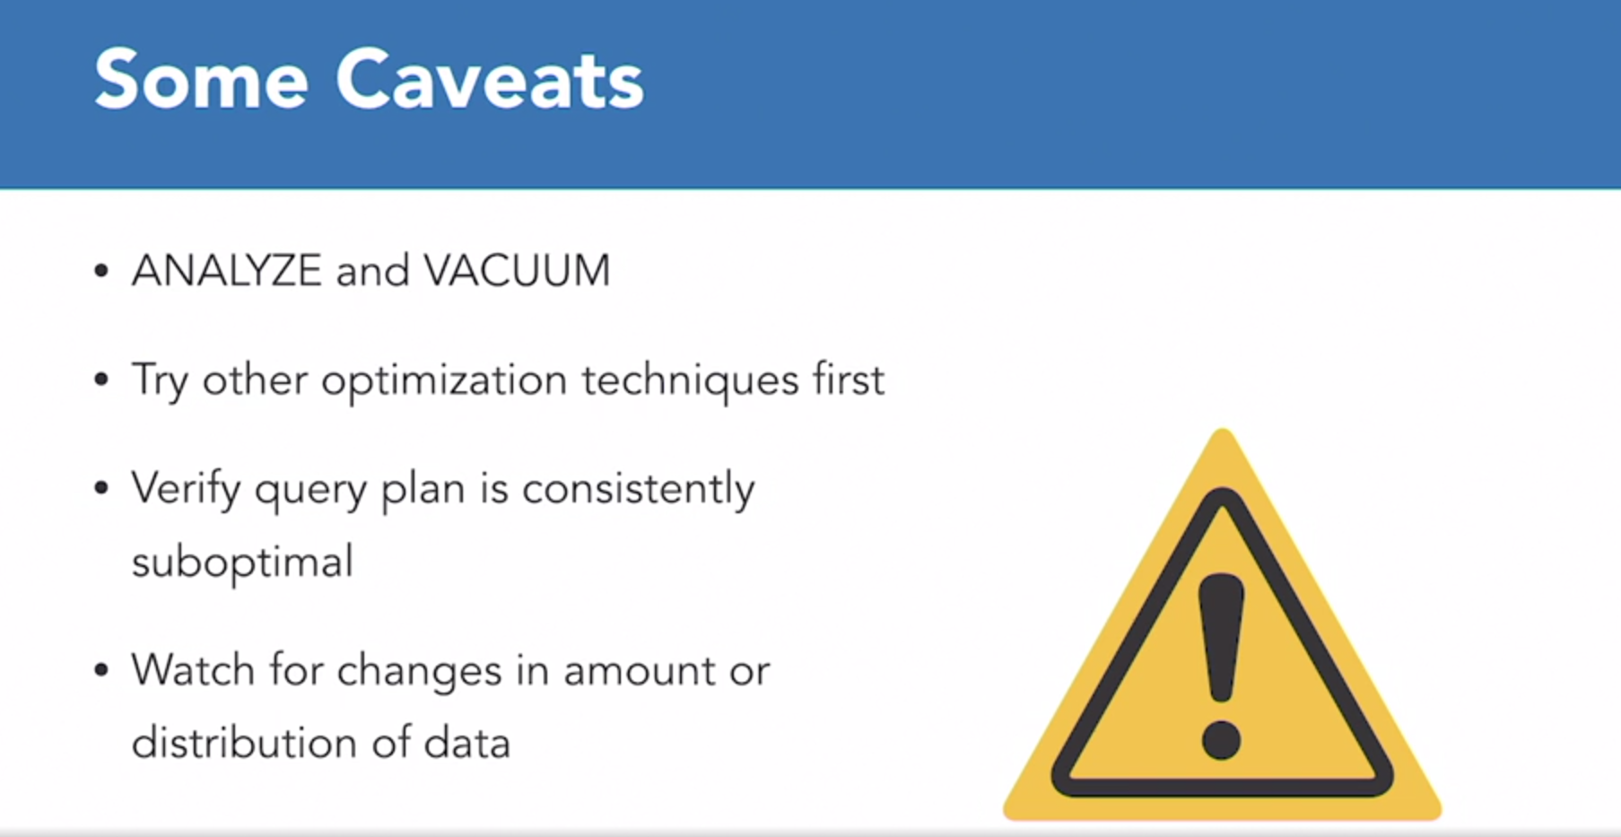

**MISCELLEANEOUS TIPS TO IMPROVE QUERY OPTIMIZATION**

* Create Indexes on Join Columns same for columns used in WHERE Clauses.
* Use covering indexes. (Indexes with all the data required for running the Query are within the Indexes, allows Query Plan Builder to avoid Data Blocks. All the required information is in the Index).
* Don’t filter on a column using equality to NULL, rather use IS NULL.
* Don’t use functions in WHERE Clauses unless have a Functional Index.
* If a plan uses Index Ranger Scan, keep the range as small as possible.
* Use equality with conditions.
* When using ORDER BY, consider using Indexes on the same column, that can help avoid sorts.
* When filtering on a Range Condition, especially dates use continuous conditions such as TRUNC (sysdate) and TRUNC (sysdate+1).
* Better not to separate date and time into separate columns; use a date time datatype.